Brian Wang

113355615

5/6/2023

Part A: Poisson Spike Trains

**PartA1 - 2**

Spike trains were created and it was found through the raster plot that each spike was relatively equally distributed.

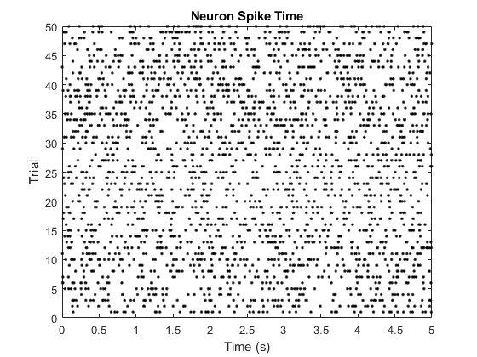

**PartA3**

We can calculate the average firing rate using this equation:

$$f=\frac{number of total spikes across trials}{N⋅T}$$

It is found through 5 repetitions of the experiment, that the average firing rate closely matched the theoretical firing rate of 10 spikes per second.

**PartA4**

Dividing the total times into bins of 0.2 seconds per bin showed that the distribution of the spikes are relatively evenly distributed with no bias towards any single bin.

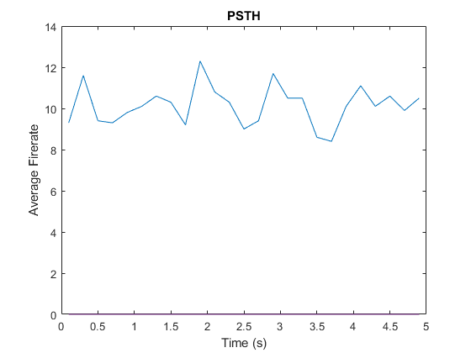

**PartA5**

The average coefficient of variability is found to be close to 1

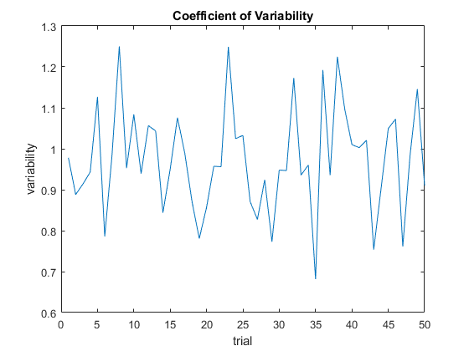

**PartA6**

The Fano Factor was found to be around 1. The lowest value obtained was 0.792 while the highest value obtained was 1.129. This is close to the theoretical Poisson spike train of FF = 1.

**PartA7**

If we were to repeat the experiment with a higher interval, we can expect to get a more accurate result. Specifically, that the CV and FF converges to 1. However, the simulation that is ran showed the Coefficient of variability converging to 1 but the Fano Factor does not do the same. It should be noted that the Fano Factor still have values that is close to 1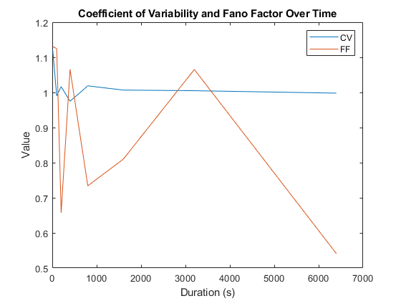

PART B: Perceptron Learning

**PartB1**

It was possible to converge to a solution for the AND and the OR problem relatively quickly. For the AND problem it took less than 50 steps in order to converge to 1, with most cases taking less than 15 approximately. It was a different case for the XOR problem, which was unable to find any convergences. Through the readings in the lecture, the or problem can be solved if an extra layer was added.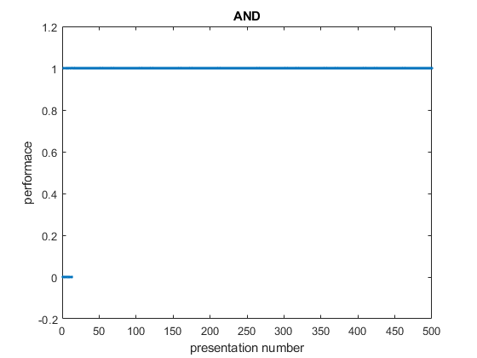

**Figure PartB1a** The performance vs presentation graph for the AND problem.

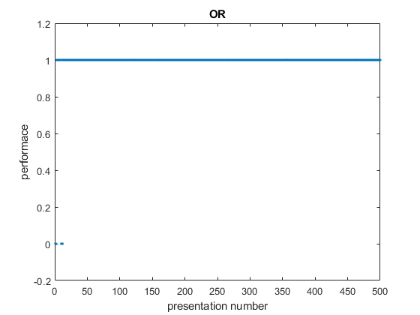

**Figure PartB1b** The performance vs presentation graph for the OR problem.

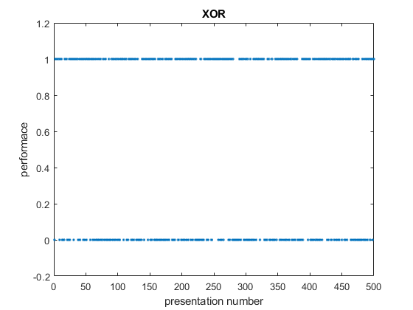

**Figure PartB1c** The performance vs presentation graph for the XOR problem. Unlike the first two graphs, this one is unable to converge to a solution.

Appendix

**PartA1**

totalT = 5;

numSpikes = 0;

lambda = 10;

SC = zeros(50);

S = zeros(100, 50);

for y = 1:50

numSpikesInTrial = 0;

cumISI = 0;

for x = 1:100

isi = -log(rand())/lambda;

cumISI = cumISI + isi;

if(cumISI < totalT)

S(x,y) = cumISI;

ISI(x, y) = isi;

numSpikes = numSpikes + 1;

numSpikesInTrial = numSpikesInTrial + 1;

else

S(x,y) = NaN;

ISI(x, y) = NaN;

end

end

SC(y) = numSpikesInTrial;

end

disp("Average: " + numSpikes/(50 * totalT));

figure(1)

plot(S,1:50,'.k');

title('Neuron Spike Time');

xlabel('Time (s)');

ylabel('Trial');

dt = 0.2;

F = zeros(totalT / dt);

for i = 1:length(F)

T(i) = 0.5 * (i * dt + (i - 1) * dt);

for y = 1:50

for x = 1:100

if(S(x,y) < i * dt && S(x,y) > ((i - 1) * dt))

F(i) = F(i) + 1;

end

end

end

F(i) = F(i)/(50 * dt);

end

figure(2)

plot(T, F);

title('PSTH');

xlabel('Time (s)');

ylabel('Average Firerate');

%Coefficient of Variability

for i = 1:50

CV(i) = std(ISI(:,i), 'omitnan') / mean(ISI(:,i), 'omitnan');

end

figure(3)

plot(1:50, CV);

title('Coefficient of Variability');

xlabel('trial');

ylabel('variability');

disp("Coefficient of Variability: " + mean(CV));

%Fano Factor

disp("Fano Factor: " + var(SC) / mean(SC));

**PartA2**

clear

totalT = [10 100 200 400 800 1600 3200 6400];

numSpikes = 0;

lambda = 10;

CVar = zeros(length(totalT));

FF = zeros(length(totalT));

for t = 1:length(totalT)

CV = zeros(50);

SC = zeros(50);

ISI = zeros(64000, 50);

for y = 1:50

numSpikesInTrial = 0;

cumISI = 0;

for x = 1:64000

isi = -log(rand())/lambda;

cumISI = cumISI + isi;

if(cumISI < totalT(t))

ISI(x, y) = isi;

numSpikes = numSpikes + 1;

numSpikesInTrial = numSpikesInTrial + 1;

else

ISI(x, y) = NaN;

end

end

SC(y) = numSpikesInTrial;

end

for i = 1:50

CV(i) = std(ISI(:,i), 'omitnan') ./ mean(ISI(:,i), 'omitnan');

end

CVar(t) = mean(CV(1));

FF(t) = var(SC) / mean(SC);

end

plot(totalT, CVar(:, 1), DisplayName='CV');

hold on

plot(totalT, FF(:, 1), DisplayName='FF');

hold off

title('Coefficient of Variability and Fano Factor Over Time');

xlabel('Duration (s)');

ylabel('Value');

legend

**PartB1**

lr = 1;

epoch = 500;

performance = zeros(epoch, 1);

%Truth table for AND. OR and XOR truth tables can be found in the bottom of

%the code

W = zeros(3, 1);

X = [1 1 -1; 1 -1 -1; -1 1 -1; -1 -1 -1];

Y = [-1 1 1 -1];

for t = 1:epoch

%accuracy test

sample = randi(size(X, 1));

sampleX = X(sample, :);

sampleY = Y(sample);

outputY = sign(dot(W, sampleX));

if outputY == sampleY

performance(t) = 1;

else

performance(t) = 0;

end

%training data

sample = randi(size(X, 1));

sampleX = X(sample, :);

sampleY = Y(sample);

outputY = sign(dot(W, sampleX));

for i = 1:3

delw = lr * (sampleY - outputY) .* sampleX(i);

W(i) = W(i) + delw;

end

end

plot(1:epoch, performance, '.');

ylim([-0.2 1.2]);

ylabel('performace');

xlabel('presentation number');

title('XOR')

%Truth Tables for OR

%X = [1 1 -1; 1 -1 -1; -1 1 -1; -1 -1 -1]

%Y = [1 1 1 -1]

%Truth Tables for AND

%X = [1 1 -1; 1 -1 -1; -1 1 -1; -1 -1 -1]

%Y = [-1 1 1 -1]